Smart Fitness Tracking System

📦 Project Modules
Project Name: Fitness and Diet Management System
GitHub link: Smart Fitness Tracking System
1. User Management Module
- User registration and login
- Profile details (age, height, weight)

2. Fitness Tracking Module
- Workout logging
- Step and activity tracking
- Calories burned calculation

3. Diet Management Module
- Daily meal tracking
- Calorie intake management
- Diet summary

4. Progress Monitoring Module
- Weekly and monthly progress
- Fitness and diet reports
- Visual progress overview

5. Dashboard Module
- Overview of fitness and diet status

- Quick access to all modules

🗓 Work Log / Progress Details

📅 18 December – Work Done
Description:
Project planning completed and module structure designed. Identified system requirements and finalized core modules including user management, fitness tracking, and diet management.

📅 8 January – Work Done
Description:
Developed basic UI structure and implemented fitness and diet tracking features. Updated progress monitoring logic and improved system flow.

📅 14 January – Work Done
📁 Folder Structure
fitness-diet-system/
├── index.html
├── css/
│ └── style.css
└── assets/
Description:
Enhanced user interface design and improved navigation. Refined fitness and diet modules and fixed minor issues to improve usability.
Dashboard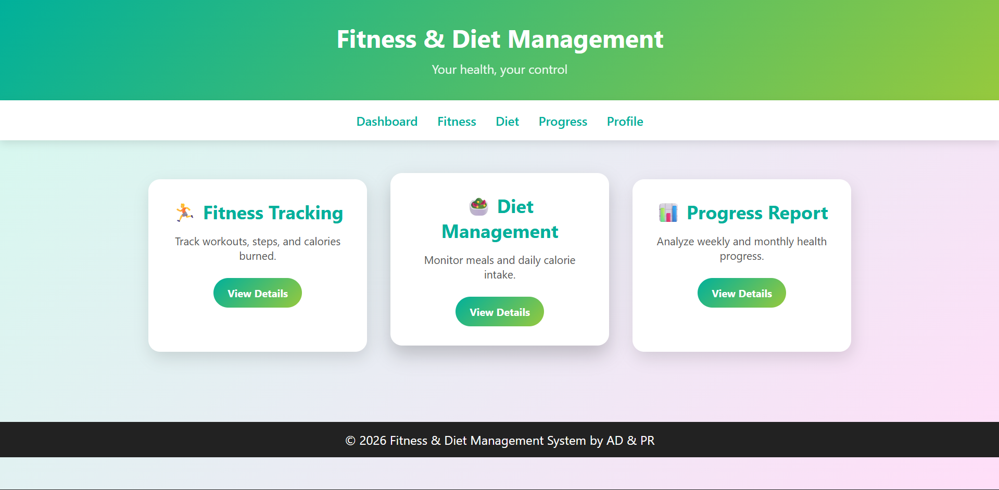

📅 21 January 2026 – Work Done
📁 Folder Structure
fitness-diet-system/
├── index.html (Dashboard)
├── fitness.html
├── diet.html
├── progress.html
|----- profile.html
└── css/
| └── style.css
\ ---- assets/
Description:
Enhanced the user interface design and improved page layout. Added navigation flow between dashboard, fitness tracking, and diet management sections. Refined CSS styling for better visual consistency and responsiveness.
Fitness
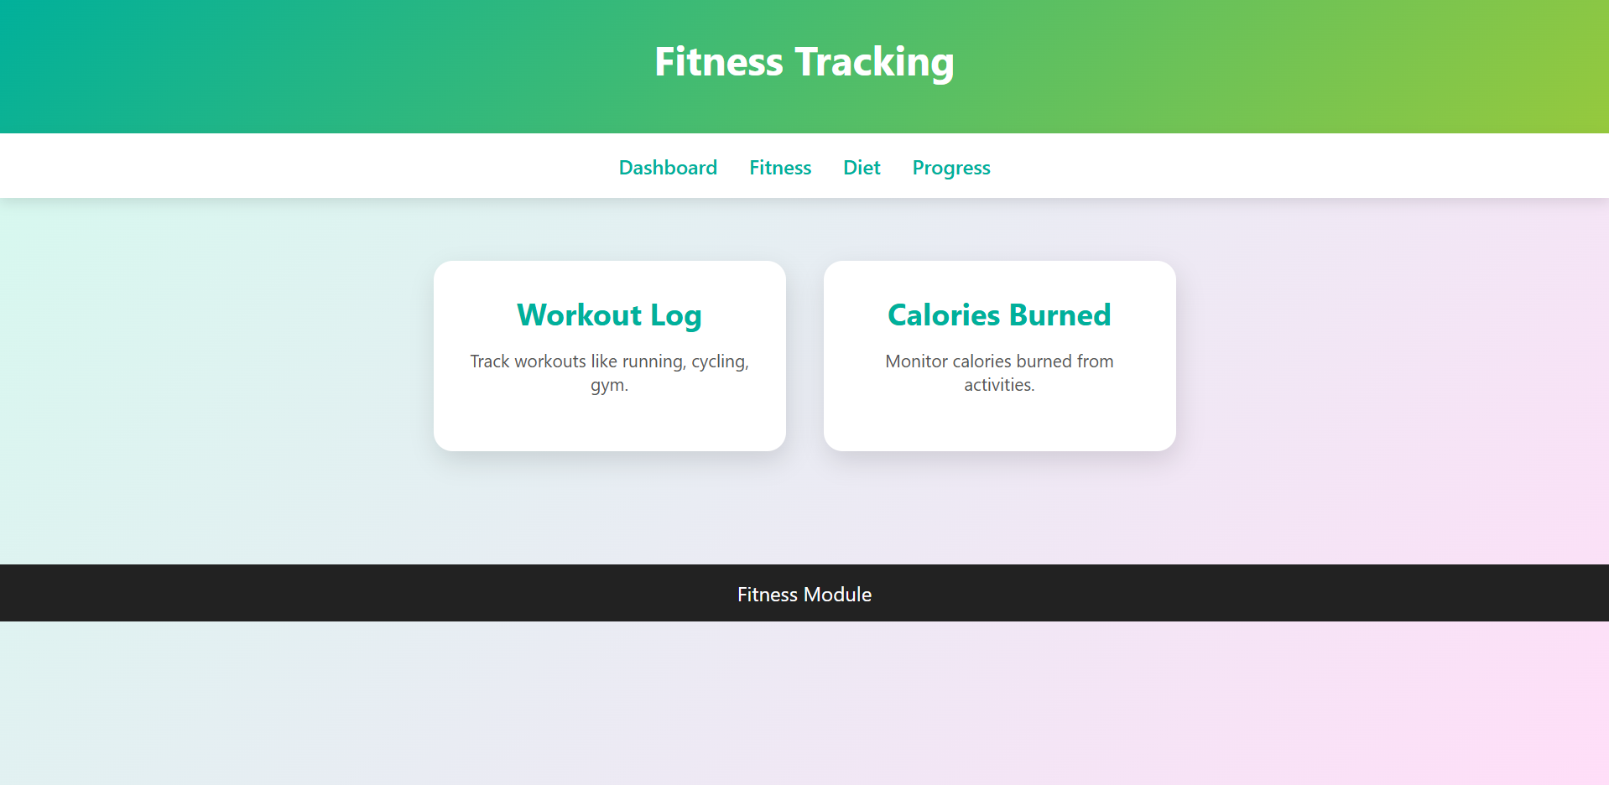

Diet
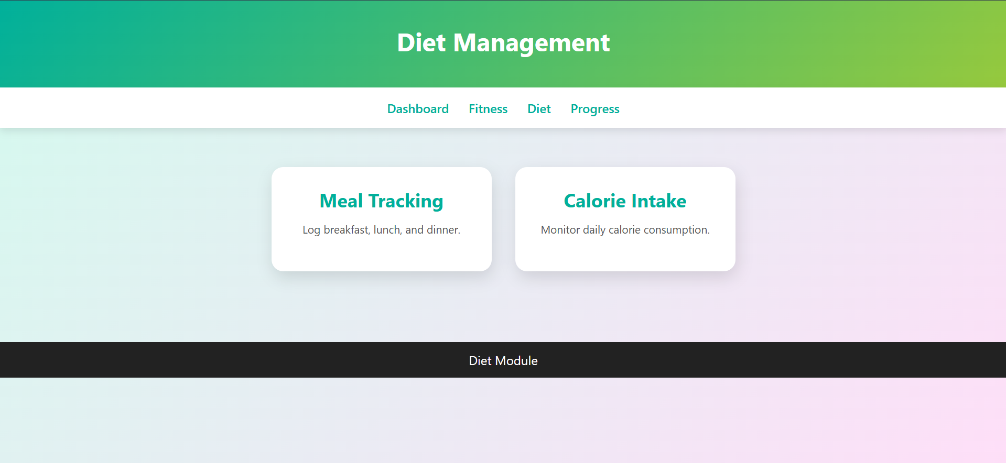

Progress
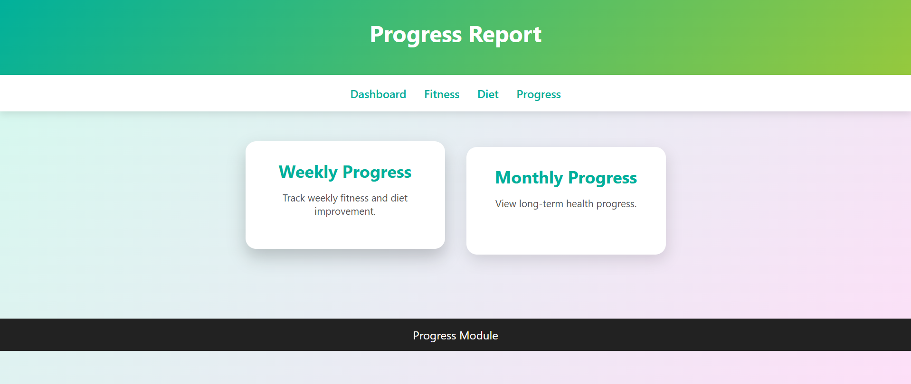

Profile
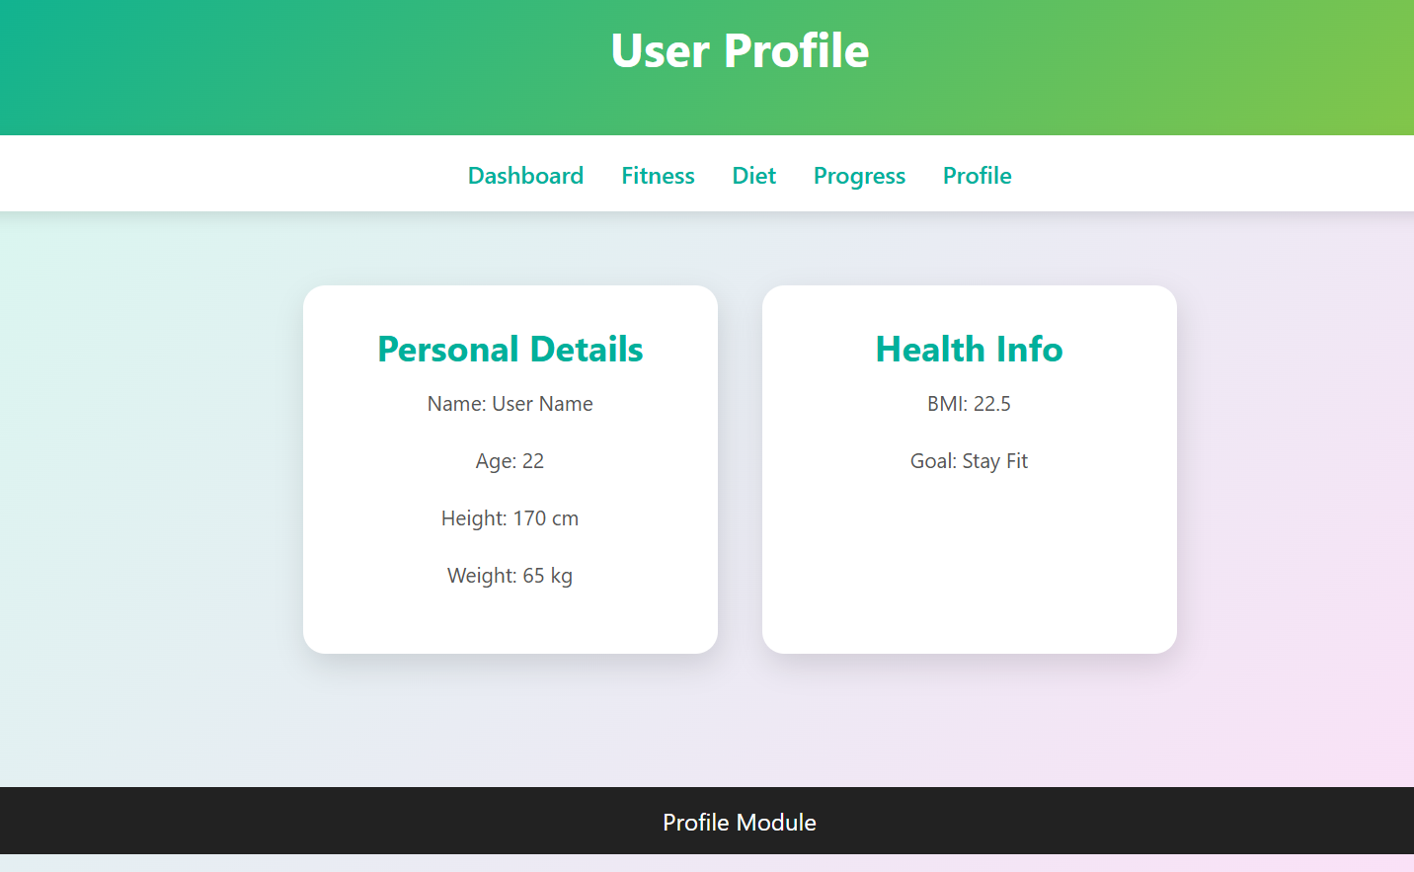

📅 22 January 2026 – Work Done
Description:
Implemented login system with profile connection. Developed editable profile form and stored user data using JavaScript localStorage. Ensured proper authentication flow and data persistence across sessions.
📁 Folder Structure
fitness-diet-system/
├── login.html
├── index.html
├── profile.html
├── fitness.html
├── diet.html
├── progress.html
├── css/
│ └── style.css
└── js/
└── app.js

Login
